CLOUD COMPUTING LAB

Submitted By: Zunaira Khatoon
Submitted To: Engr. Muhammad Shoaib
Roll No: BSE-2023-074
Section: V-B
LAB 9

Task 1: Install GH CLI, authenticate for Codespaces and create/connect to a Codespace (in Codespace environment)
(Local desktop) Install GitHub CLI (Windows example via winget):
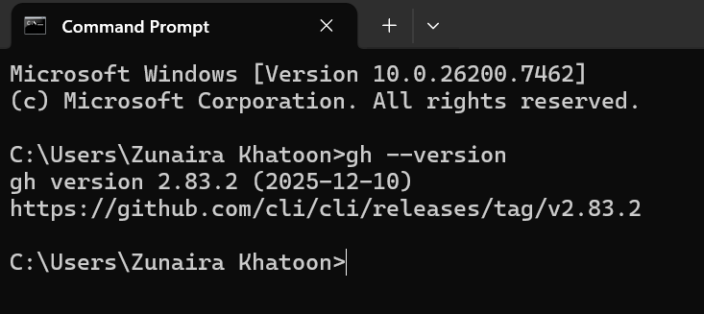
(Local) Authenticate GH CLI for Codespaces:
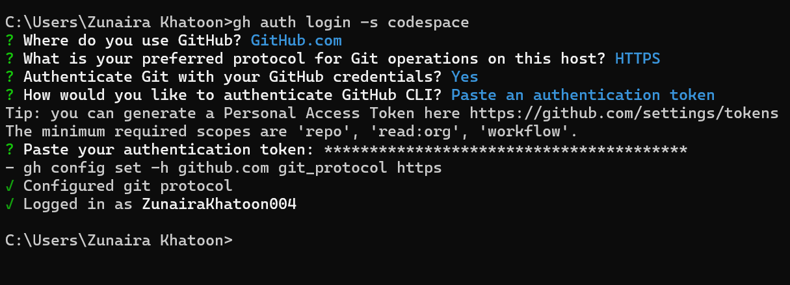
(Local) List available Codespaces (optional verification):
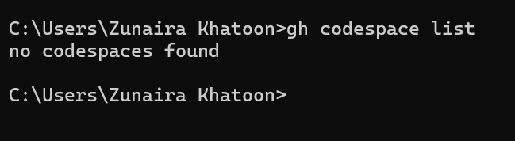
(Local) Create or connect to a Codespace. To create a new codespace from the current repo:
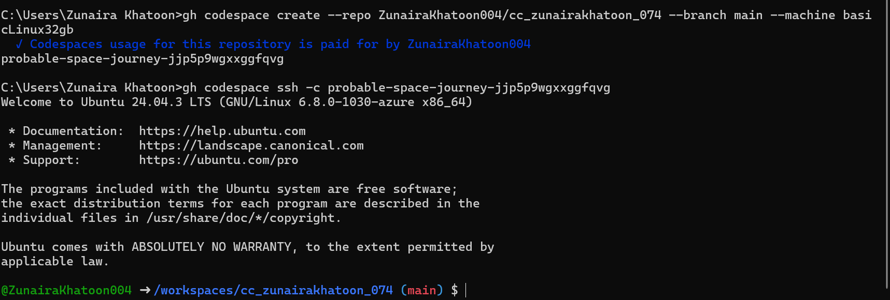

Task 2: Install AWS CLI in Codespace and configure it
Download and install AWS CLI:
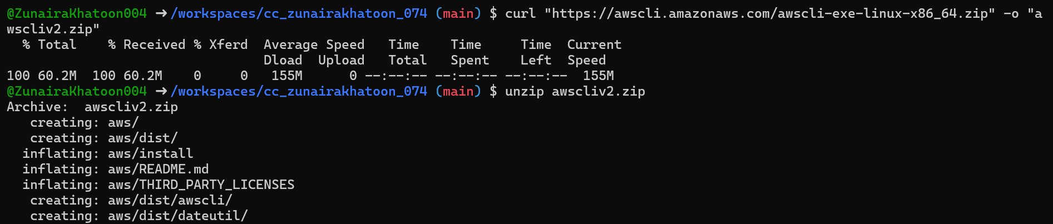
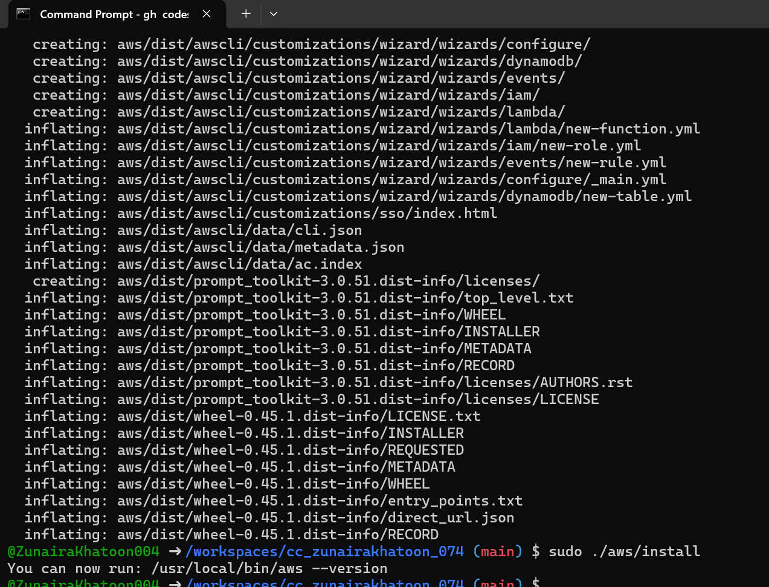
Verify installation:
Configure the AWS CLI (you will provide Access Key ID and Secret Access Key for a user with permissions, or use root/IAM user you prepared for the lab):
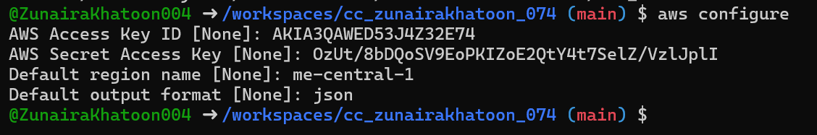
Verify credentials/config files:
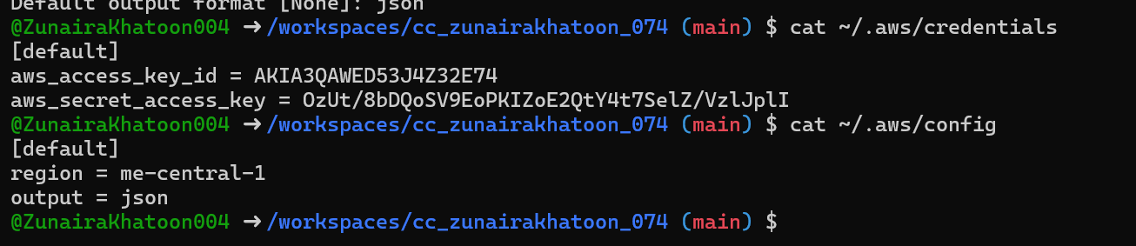
Verify connectivity (you should see a JSON result showing your caller identity):
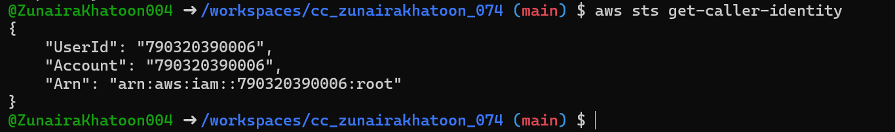

Task 3: Create and update EC2 security group rules (use Codespace public IP)
Create a security group (substitute your VPC id):
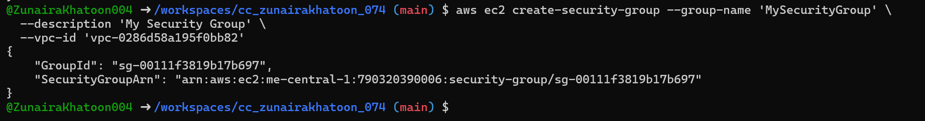
Inspect the security group (initially ingress will be empty or default):
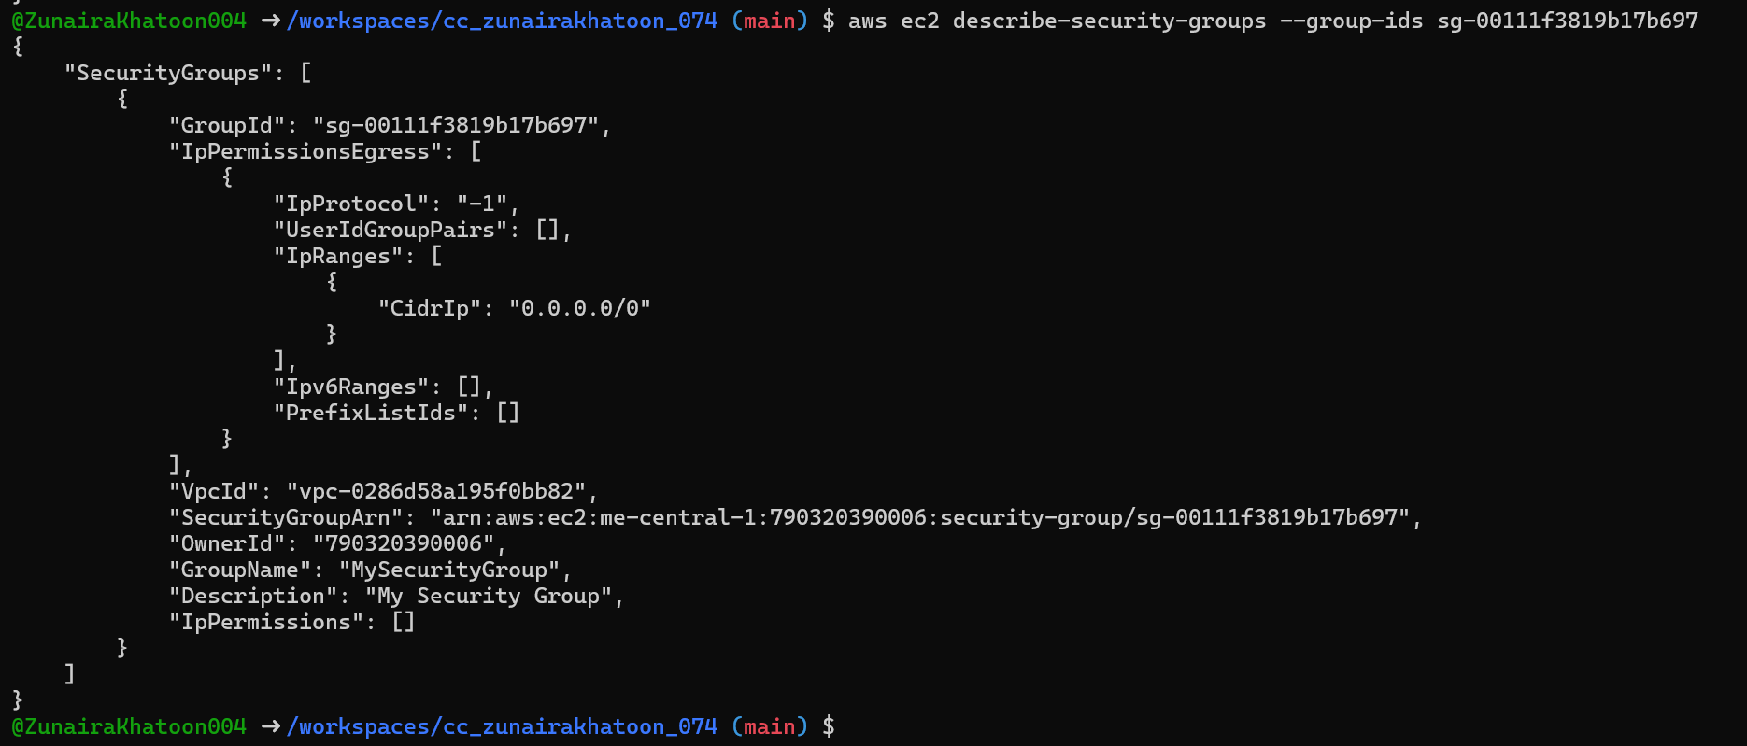
Get your Codespace public IP (from inside the Codespace):
Authorize SSH inbound on port 22 from your Codespace IP:
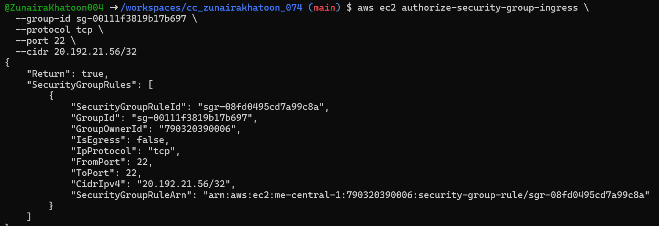
Verify ingress rule appears:
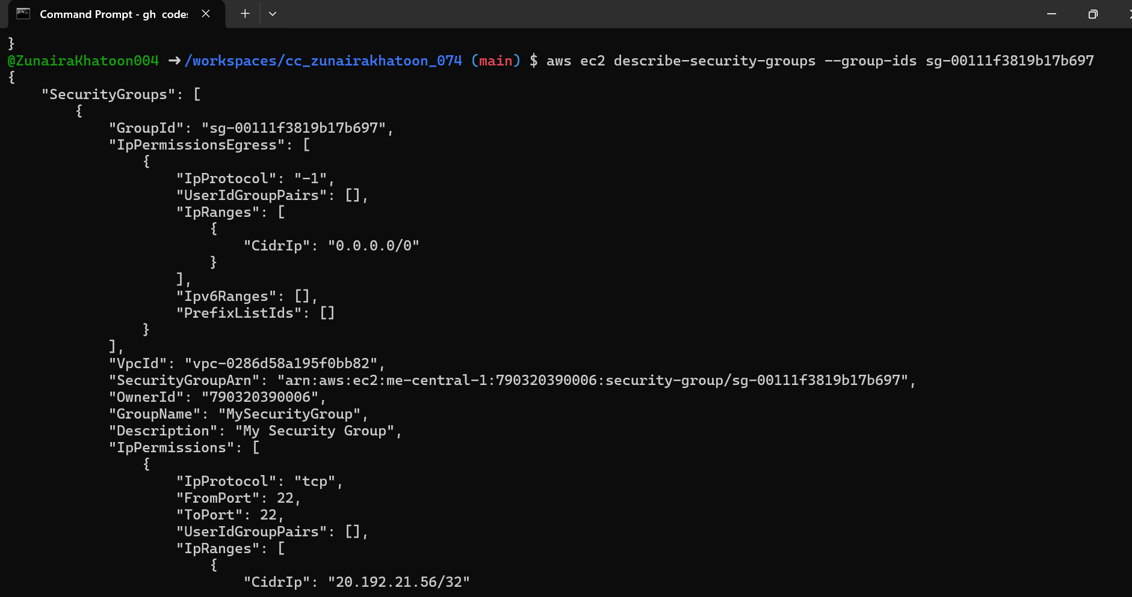
Add an HTTP rule (port 80) using ip-permissions JSON:
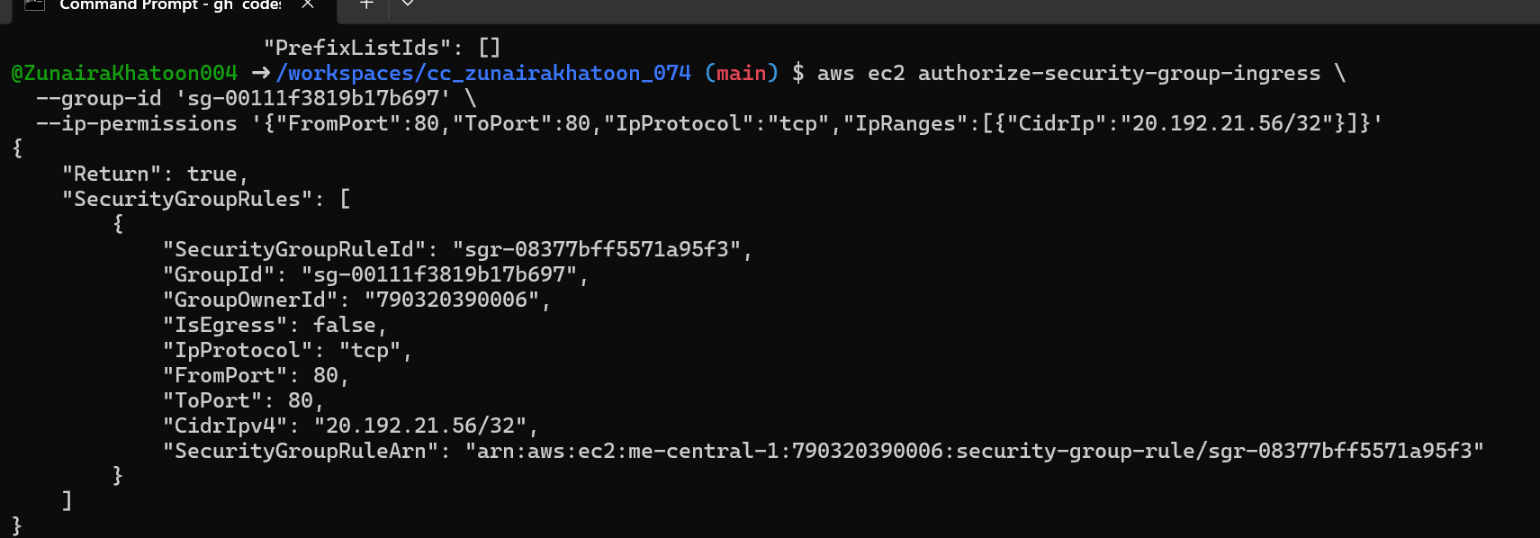
Verify both ingress rules are present:
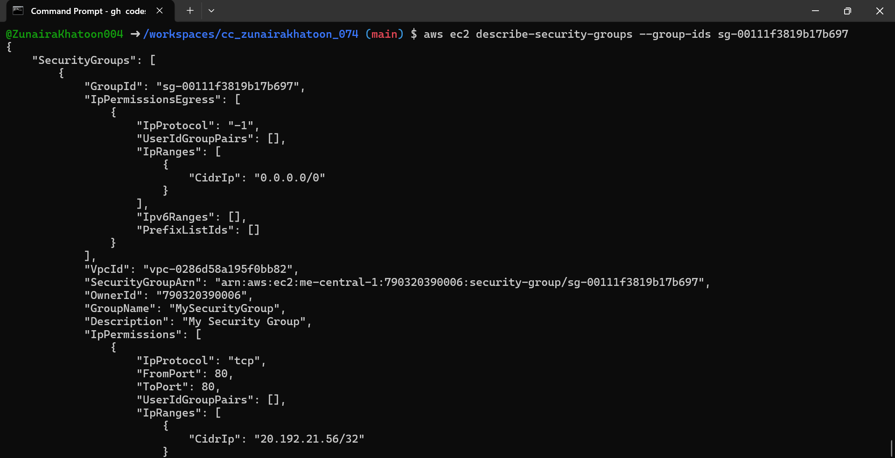

Task 4: Create EC2 key pair, launch instance, fix SSH permissions, SSH from Codespace (or forward) and test connectivity
Create the key pair and save the PEM file into the Codespace workspace:
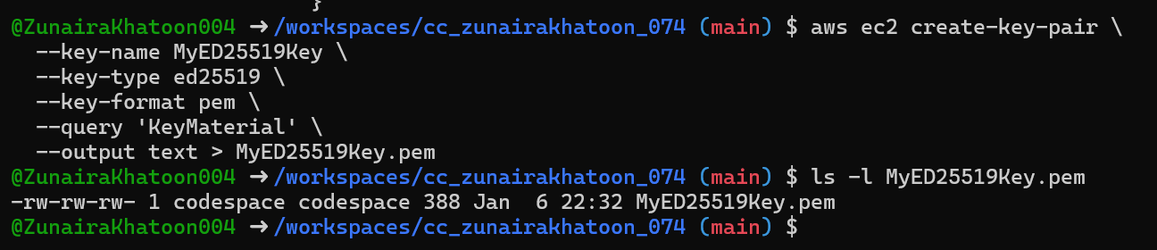
View created key pairs:
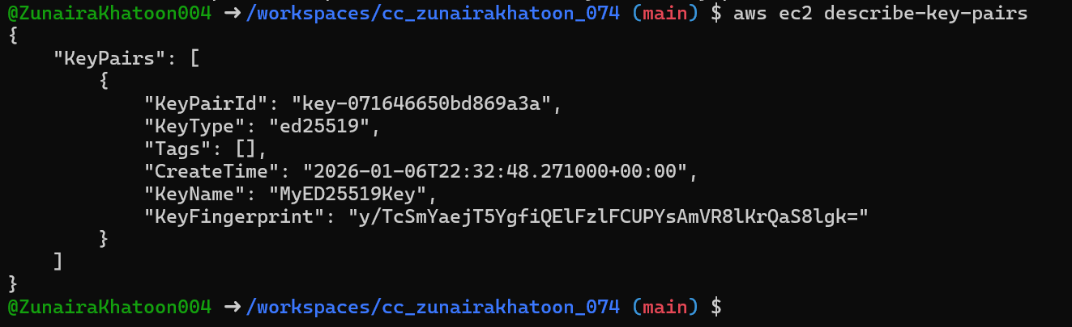
(Do not) Delete key pair:
Launch an EC2 instance (example values — replace IDs with ones from your account/region):
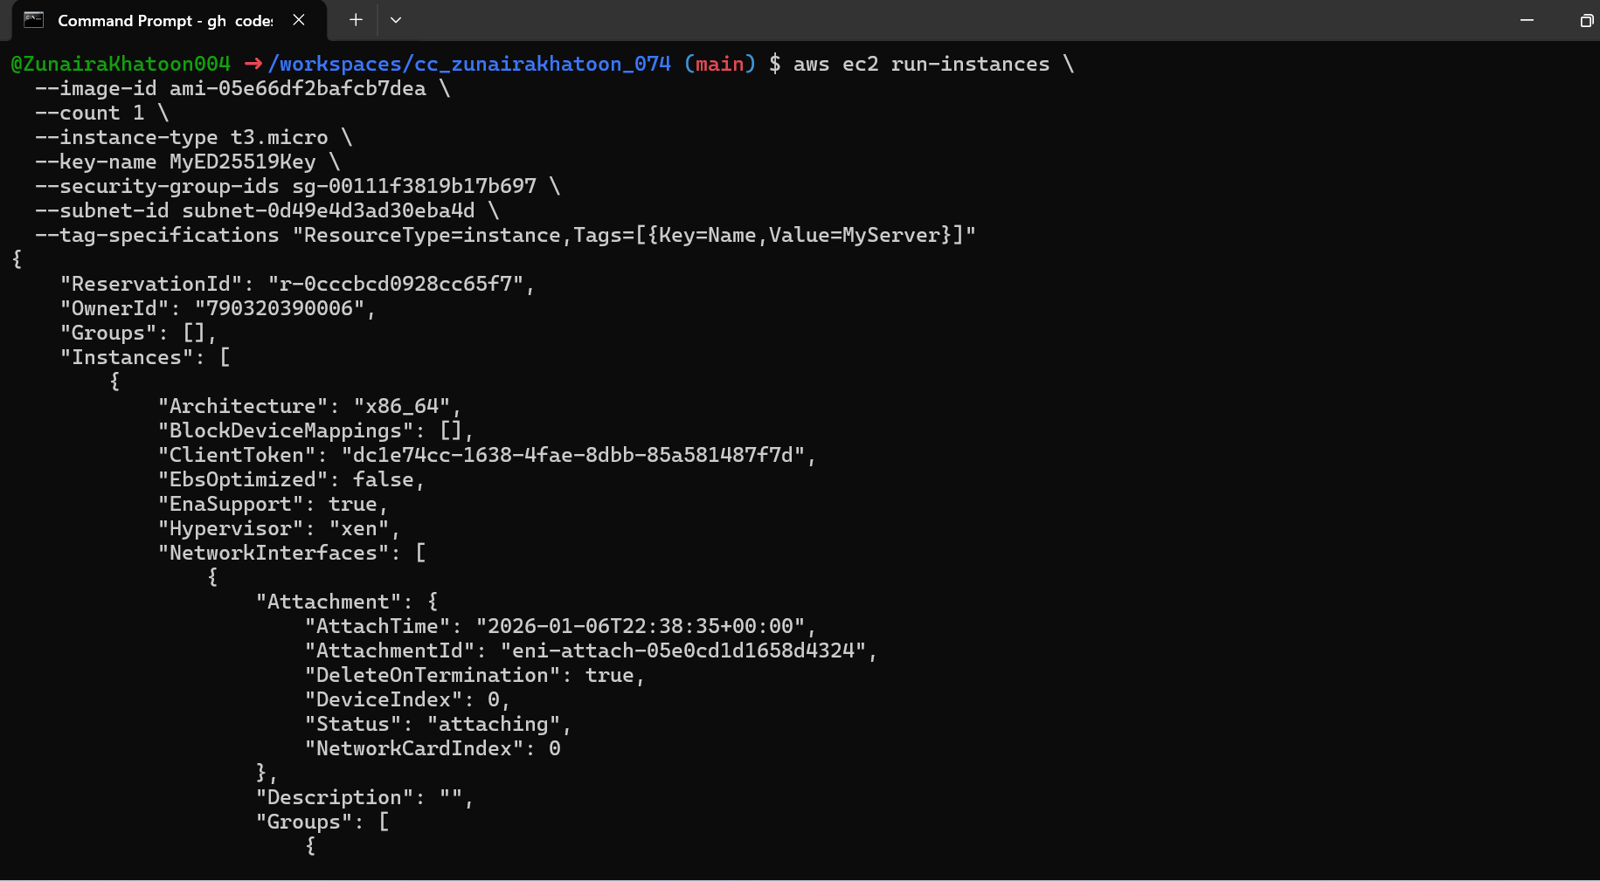
Get the public IP address of your instance:
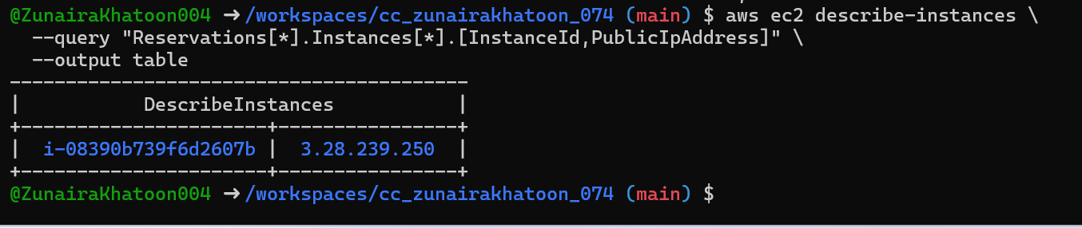
Attempt SSH into the instance from the Codespace or from a machine whose IP is allowed in the security group:
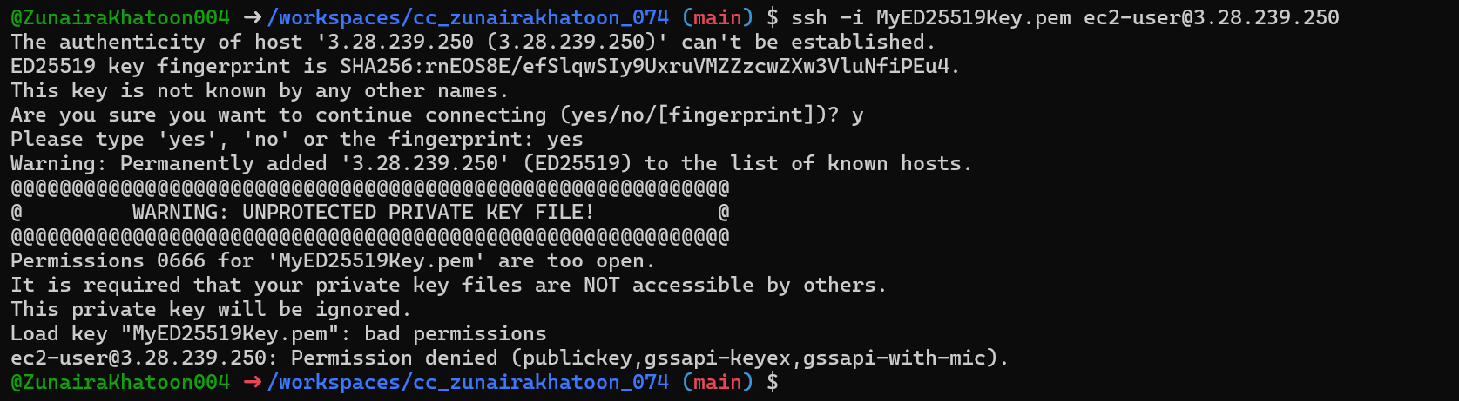
Stop, start and (optionally) terminate the instance:
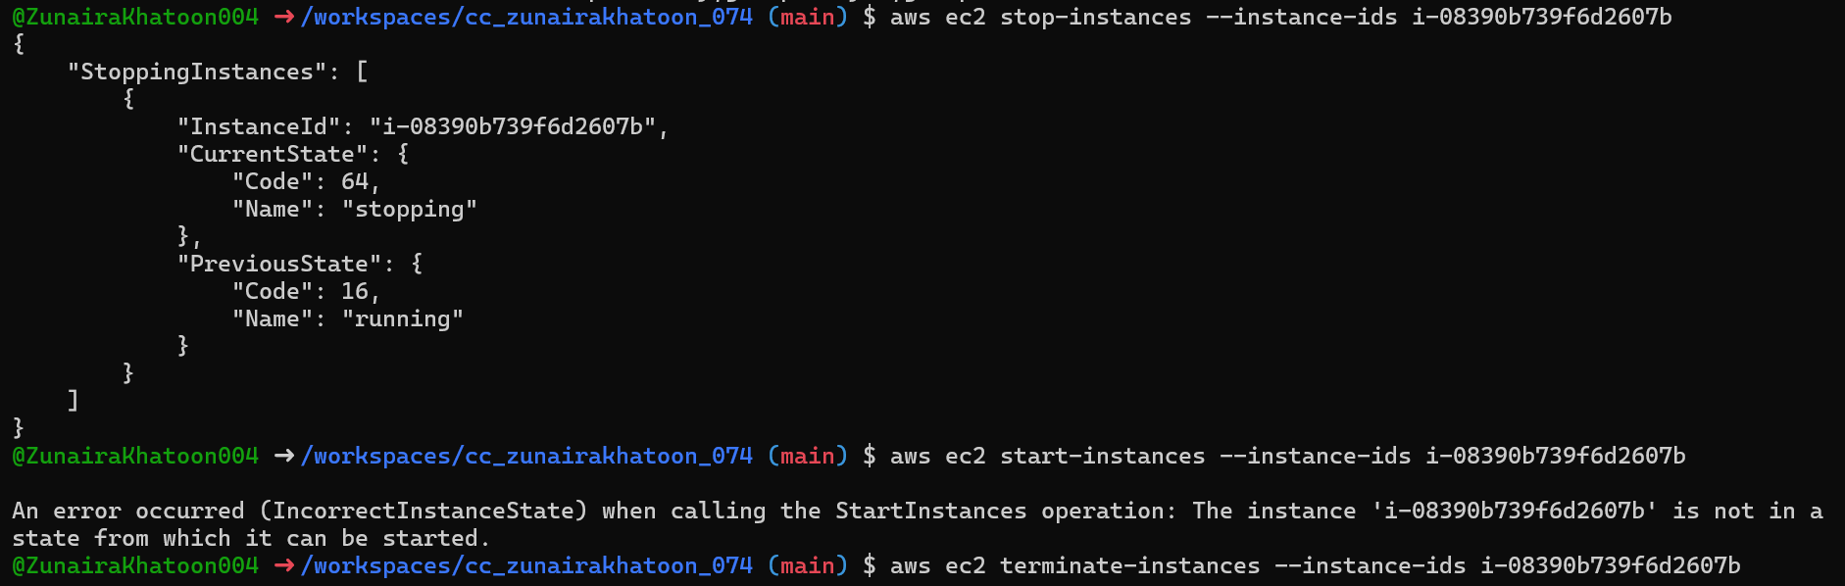

Task 5: Inspect AWS resources (describe-*) commands
Use describe commands to list and inspect AWS resources.
aws ec2 describe-security-groups
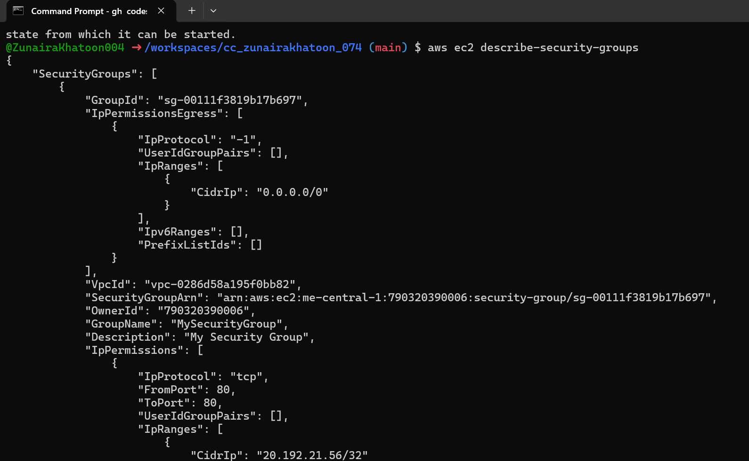
aws ec2 describe-vpcs
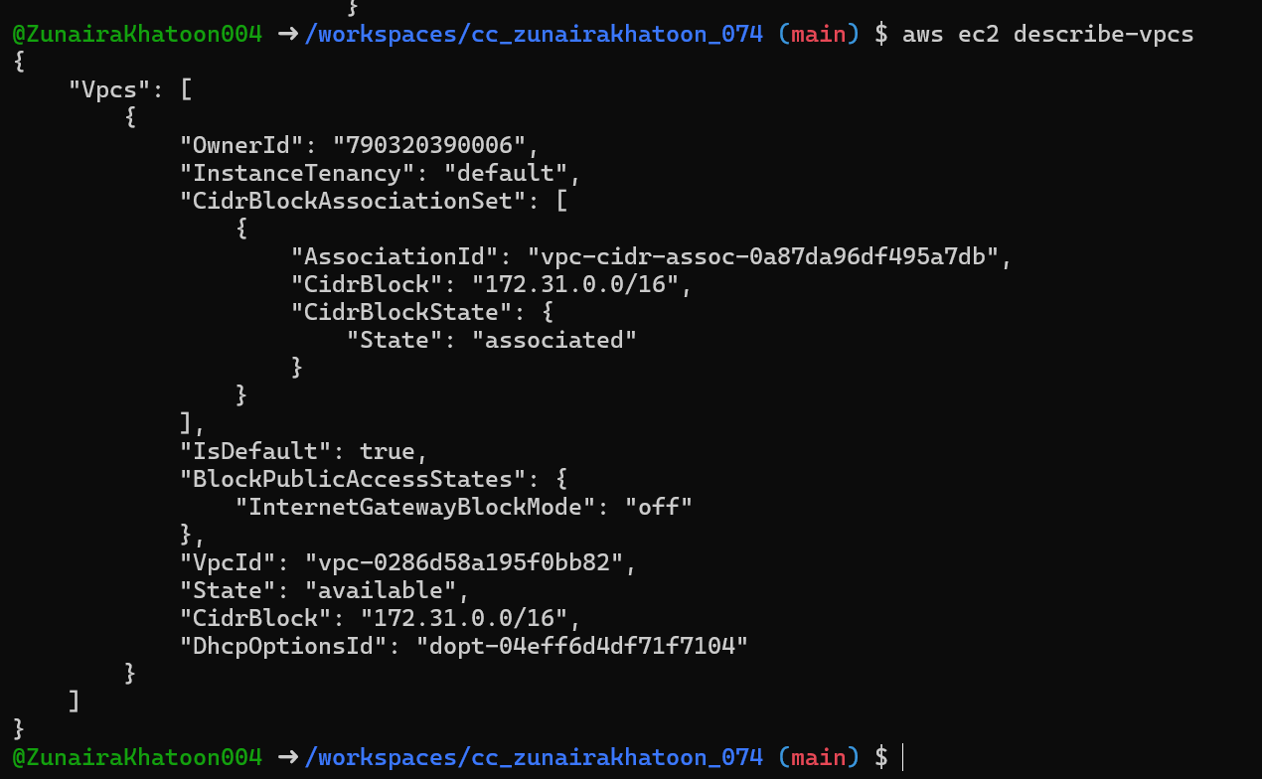
aws ec2 describe-subnets
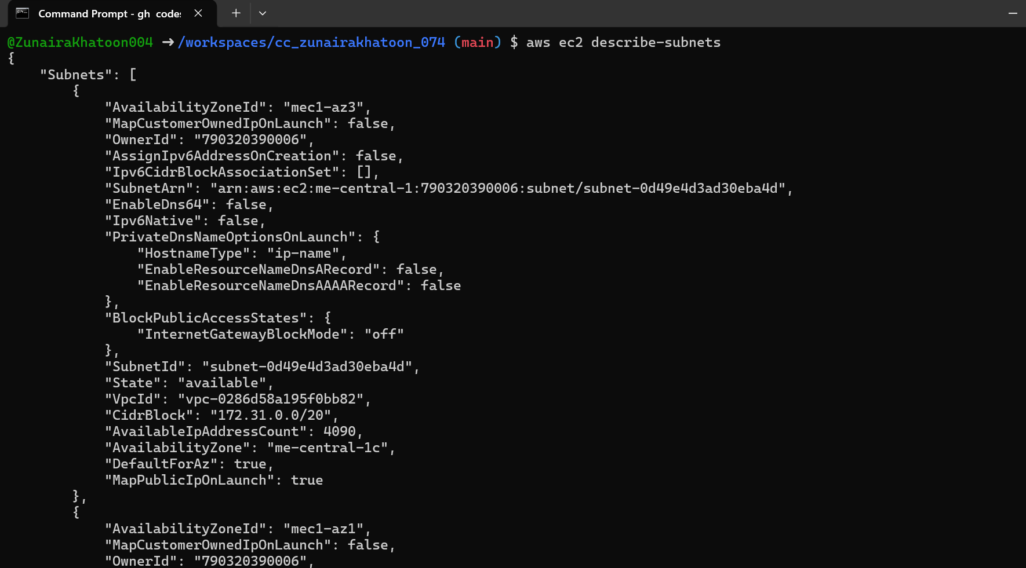
aws ec2 describe-instances
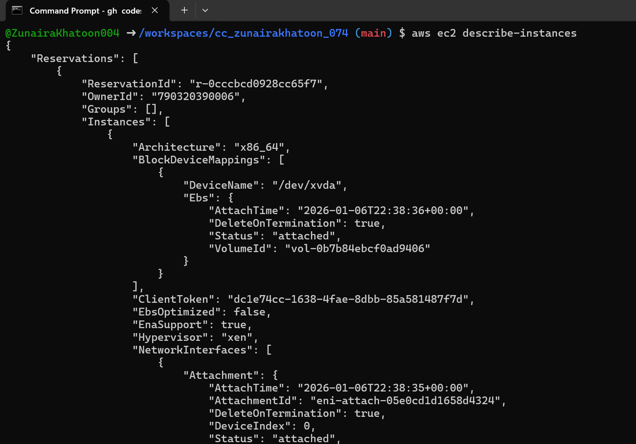
aws ec2 describe-regions
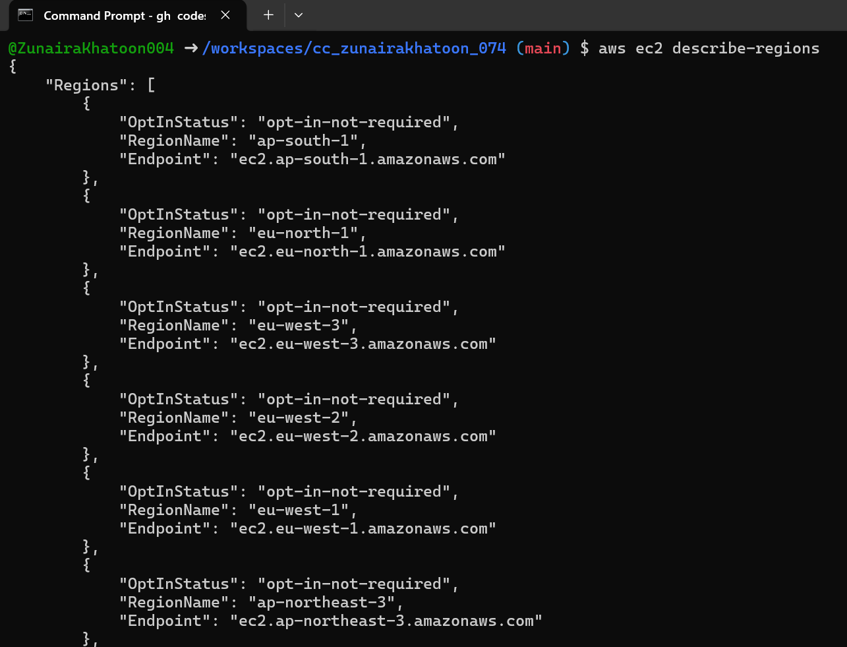

aws ec2 describe-availability-zones
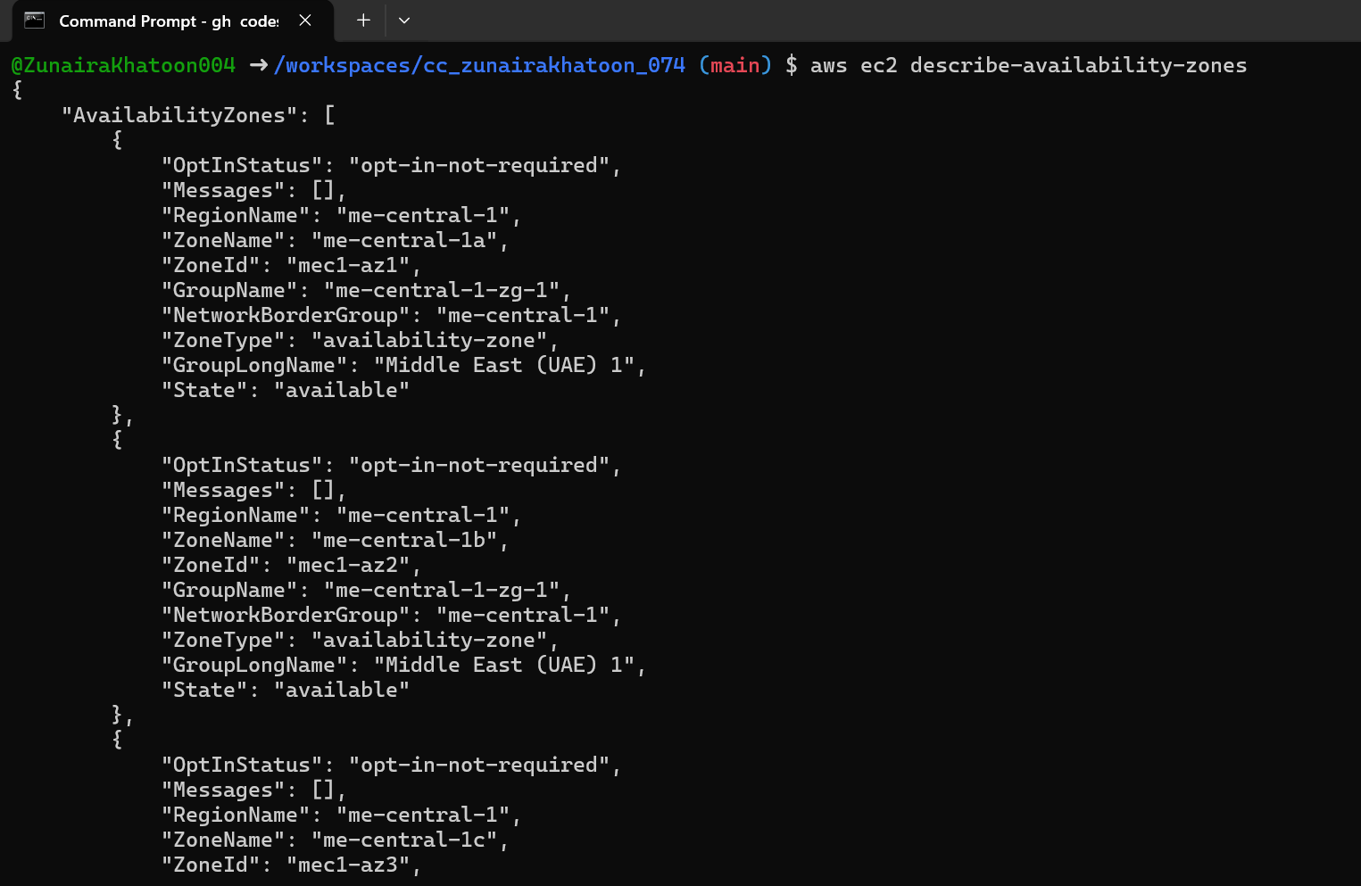

Task 6: Create IAM group and user, attach policies, create console login and access keys
Create group:
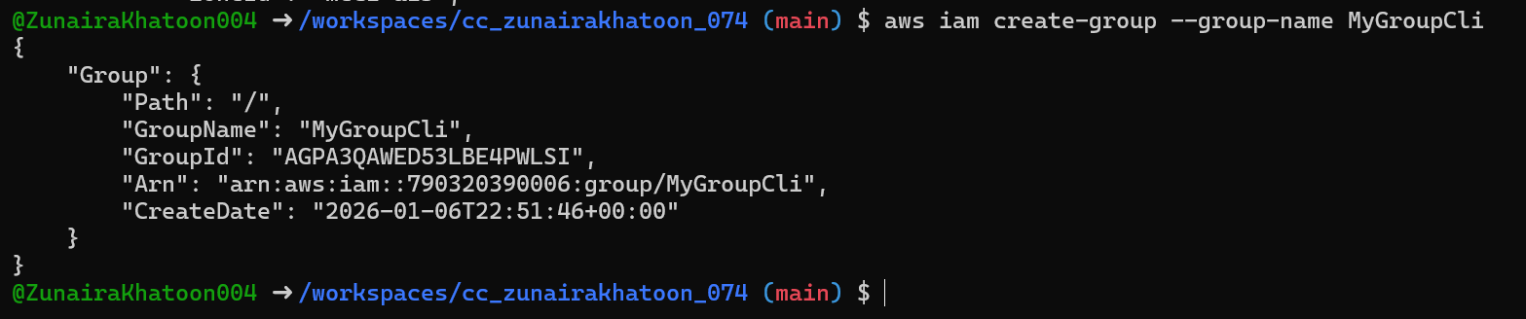
Get group details:
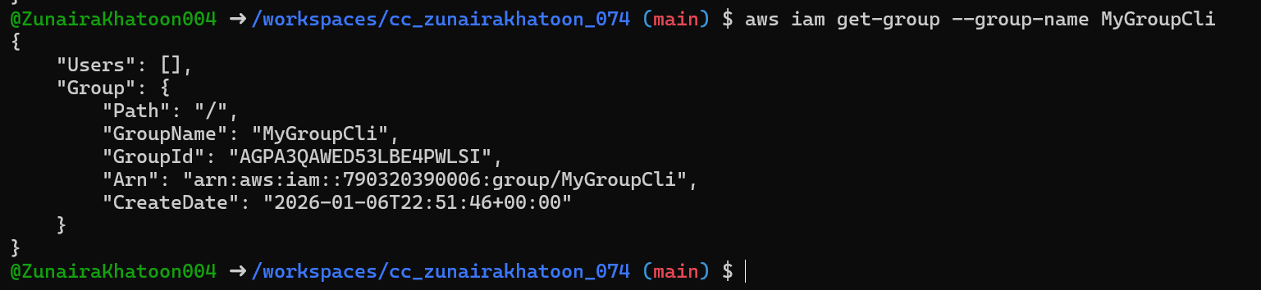
Create user:
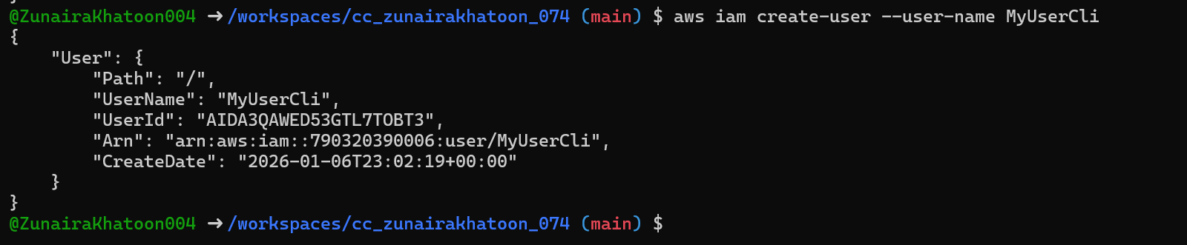
Get user details:
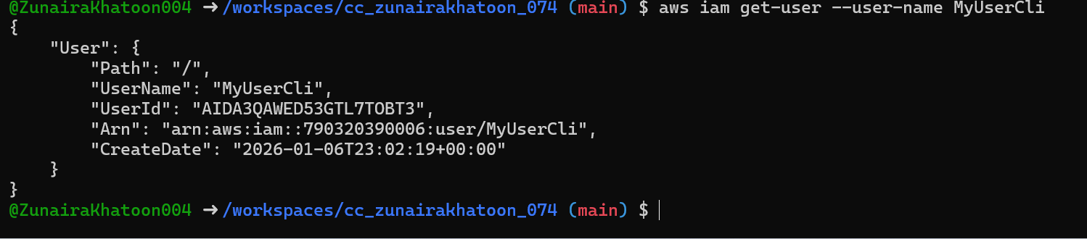
Add user to group:
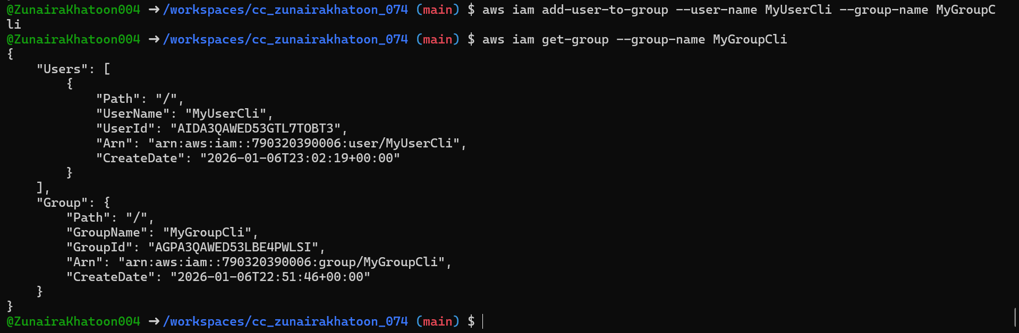
See group again:
List policies that mention EC2:
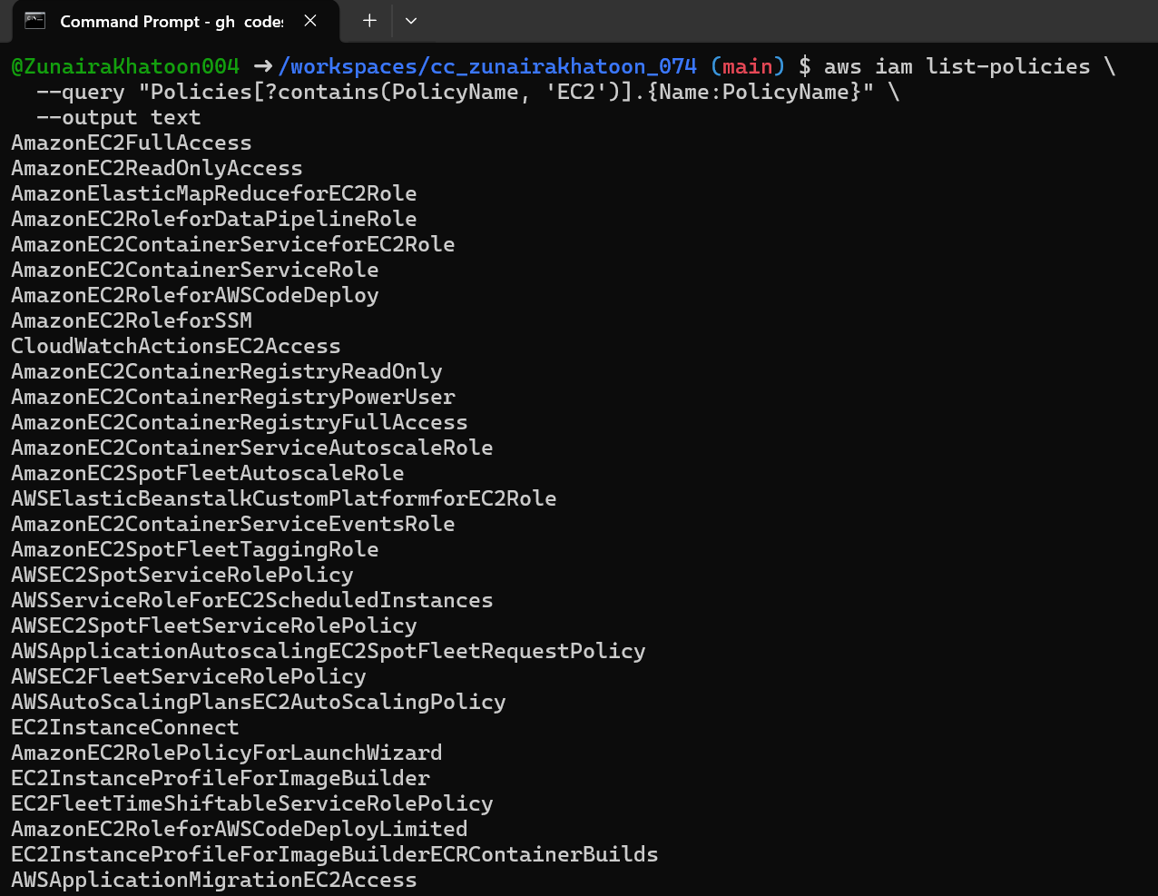
Get ARN for AmazonEC2FullAccess (example query):
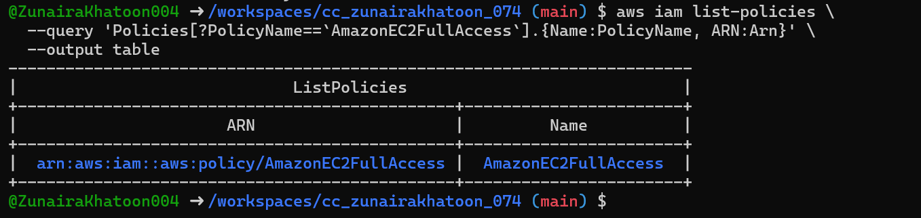
Attach policy to group (use the ARN you retrieved):
List attached policies for the group:
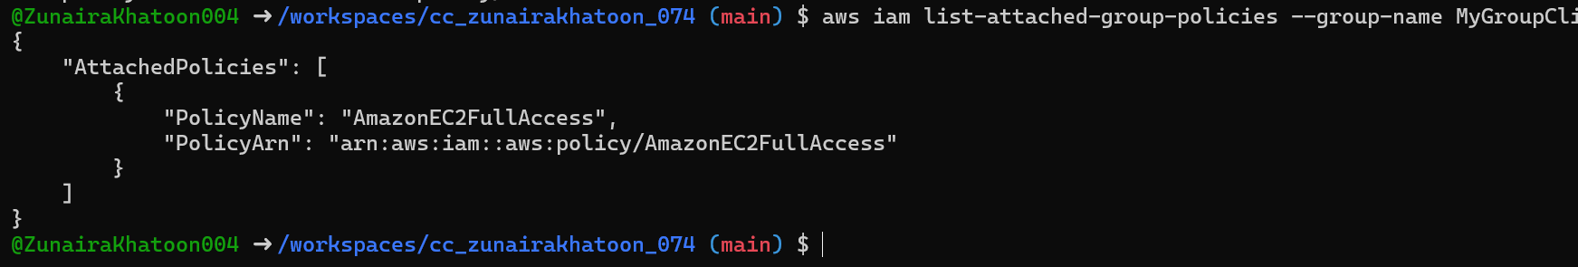
Create a console login profile for the user:
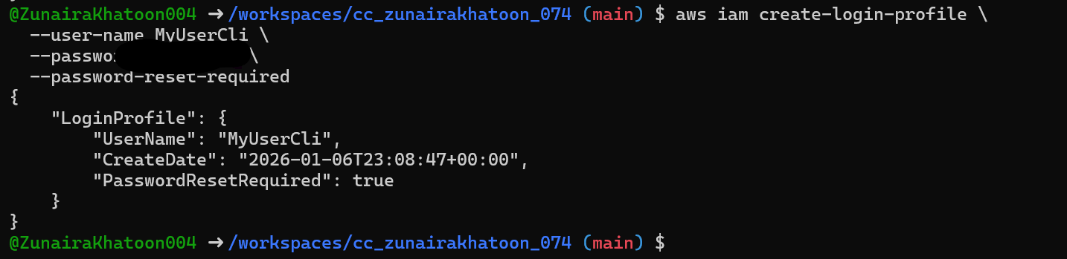
If the user cannot change password, attach IAMUserChangePassword to the group temporarily:
attach
Detach
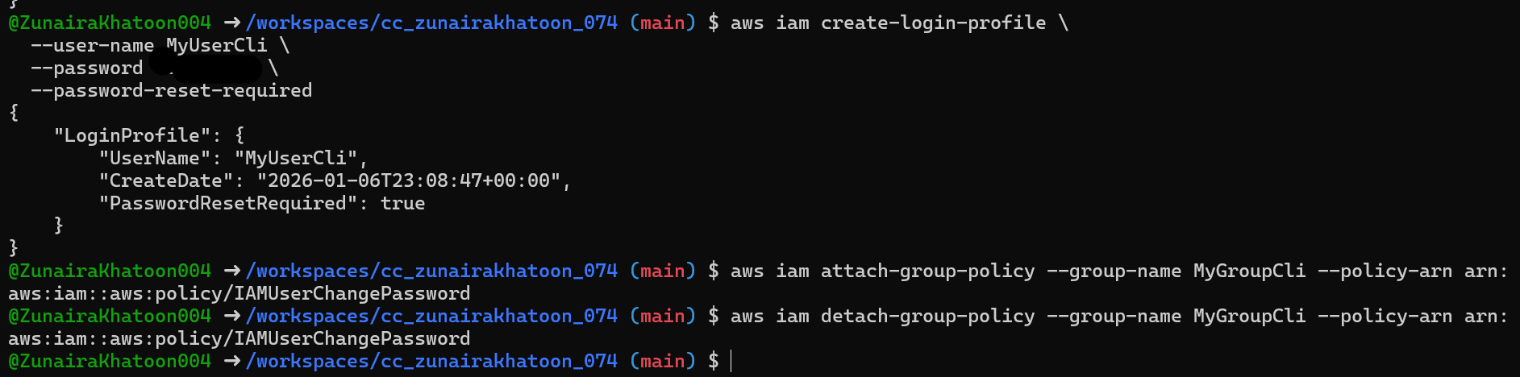
Create access keys for the user (save AccessKeyId and SecretAccessKey securely):
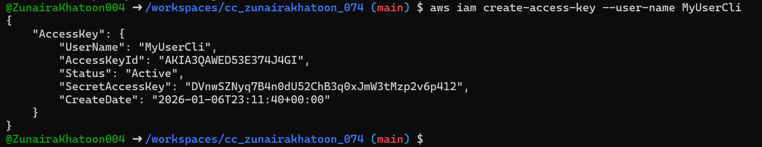
List access keys:
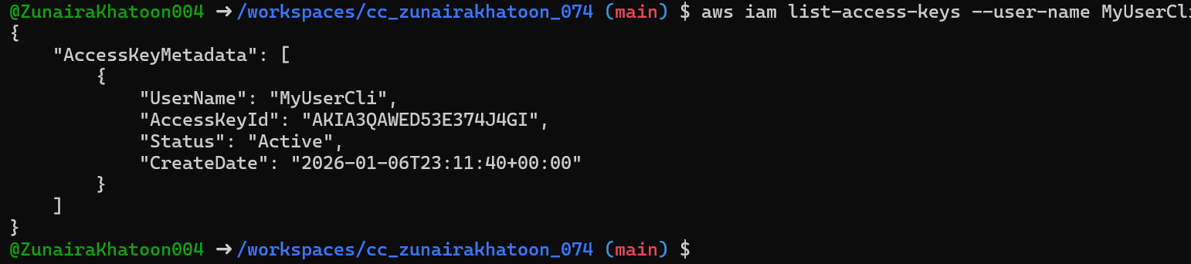
(Don't) Delete access key:
Use environment variables to authenticate as that user in the Codespace:
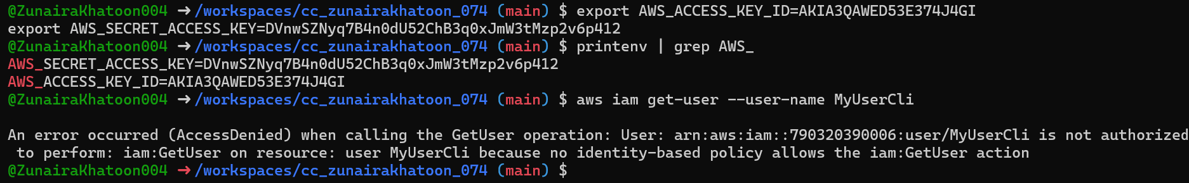
After clearing or switching credentials, repeat get-user and save:
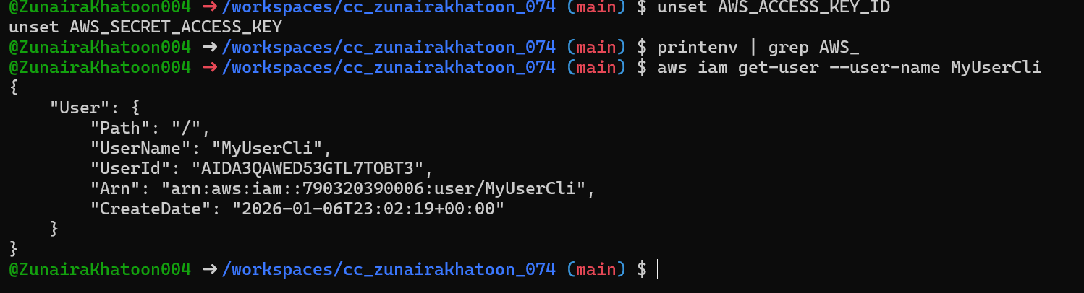

Task 7: Practice describe-instances filters and queries
run each and take a screenshot immediately after):
aws ec2 describe-instances \
--filters "Name=tag:Name,Values=MyServer" \
--query "Reservations[*].Instances[*].PublicIpAddress" \
--output text
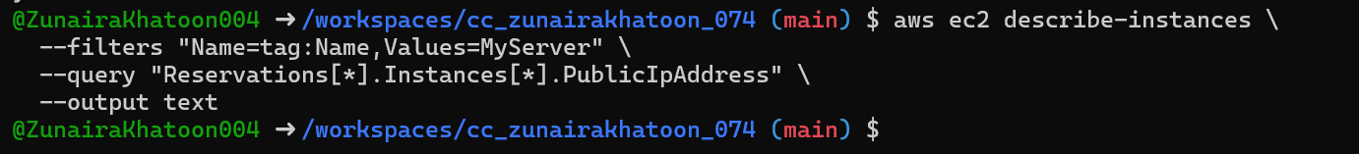
aws ec2 describe-instances \
--filters "Name=instance-type,Values=t3.micro" \
--query "Reservations[].Instances[].InstanceId" \
--output table
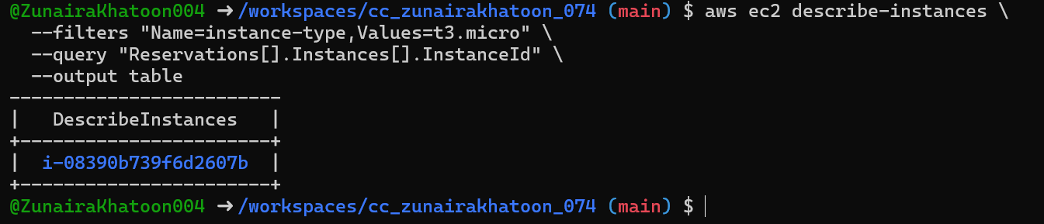
aws ec2 describe-instances \
--filters "Name=subnet-id,Values=subnet-0600df5fa8ce60857" \
--query "Reservations[*].Instances[*].InstanceId" \
--output table
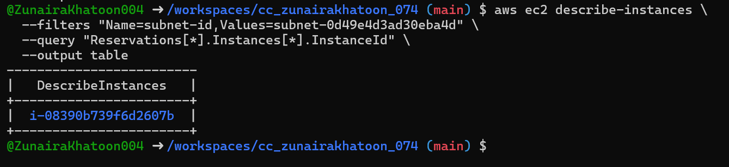
aws ec2 describe-instances \
--filters "Name=vpc-id,Values=vpc-06be85cd81b657192" \
--query "Reservations[*].Instances[*].InstanceId" \
--output table
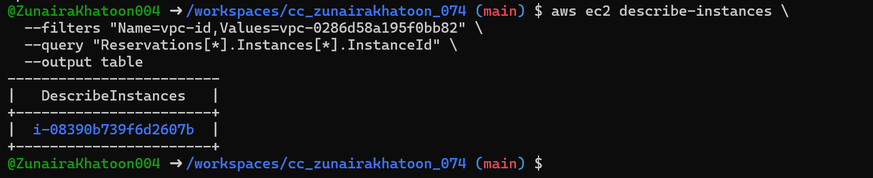

Task 8: Query outputs and format them for reporting
run each and take a screenshot immediately after
aws ec2 describe-instances \
--filters "Name=tag:Name,Values=MyServer" \
--query "Reservations[*].Instances[*].[InstanceId,PublicIpAddress,Tags[?Key=='Name'].Value|[0]]" \
--output table
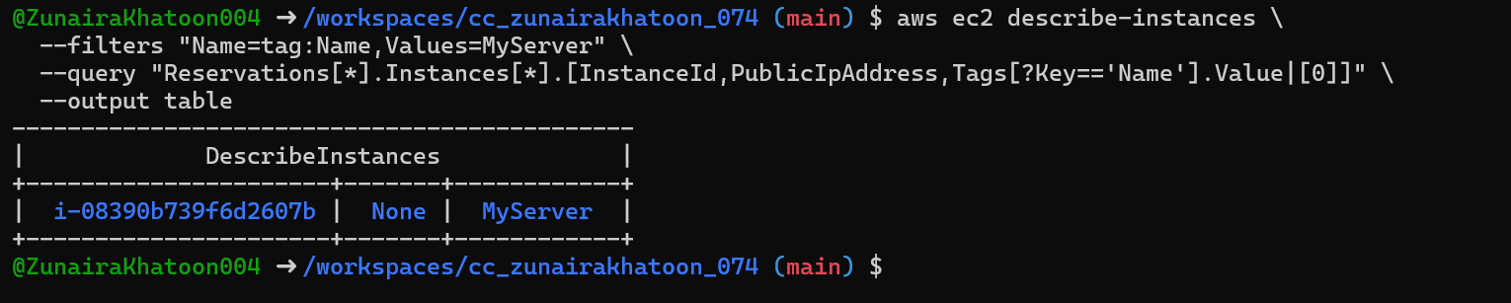
aws ec2 describe-instances \
--query "Reservations[*].Instances[*].[InstanceId,State.Name]" \
--output table
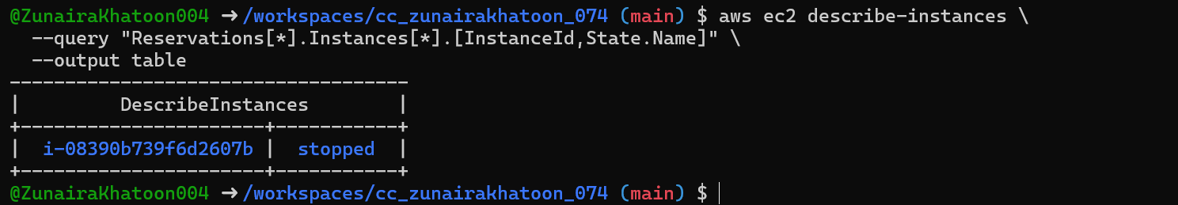
aws ec2 describe-instances \
--query "Reservations[*].Instances[*].[InstanceId,InstanceType,Placement.AvailabilityZone]" \
--output table
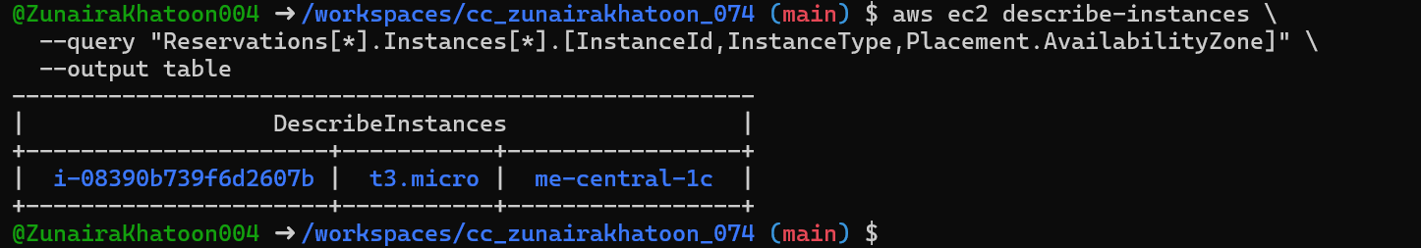

Cleanup — Remove resources to avoid charges
- Terminate instances:
aws ec2 terminate-instances --instance-ids i-EXAMPLE1234567890
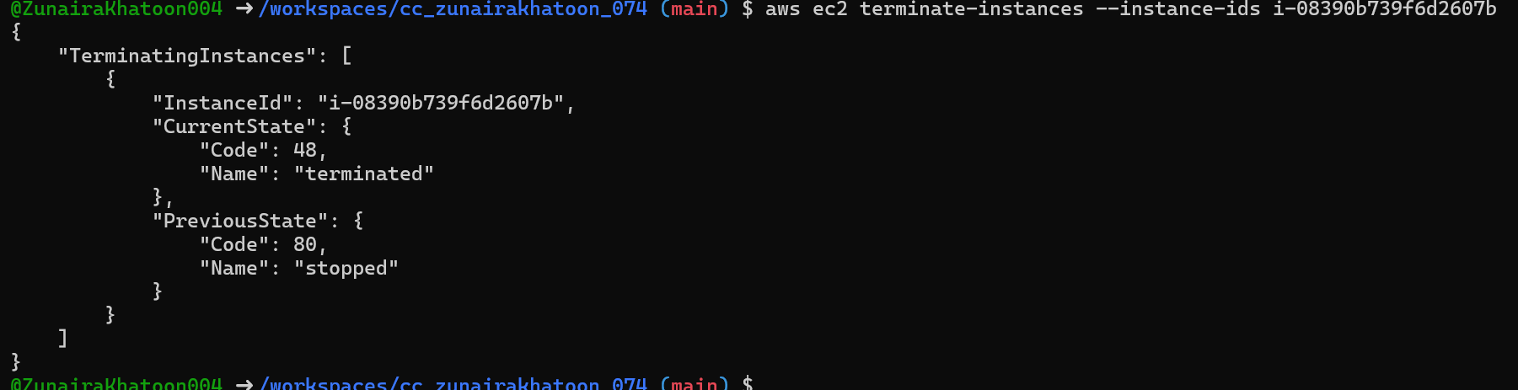
- Delete EBS volumes & snapshots (if any):
- Delete security group and key pair:
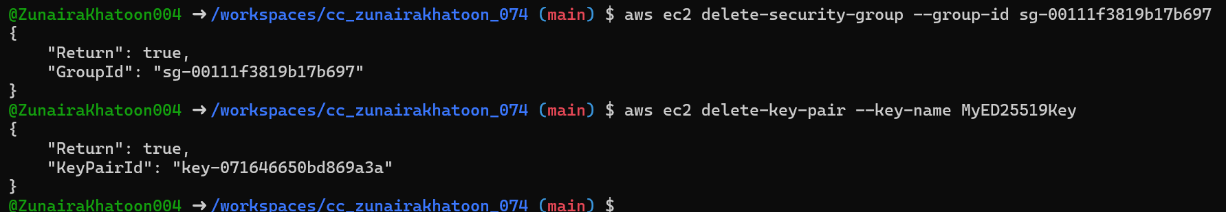
- Remove IAM users, access keys, groups:
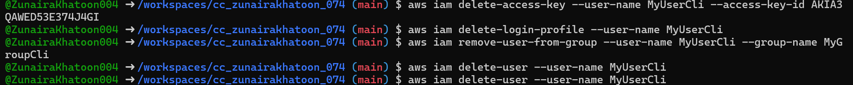
- Final verification (billing/resource groups):
